

Proposal

Final Stack
Ali Belikırık
Beyza Değirmenci
İnan Özşahin
Özge Doğan

1. Project Title :

AI-Enhanced Data Preprocessing and Ingestion Layer

2.Problem Definition and Objectives:

Problem Definition :
In Neonatal Intensive Care Units (NICUs); medical devices, sensors, and Hospital Information Systems (HIS) often operate independently and use incompatible data formats, which prevents clinicians from obtaining a unified, real-time view of newborns’ medical conditions. Moreover, raw data from sensors are frequently noisy, incomplete, or non-standardized; which reduces the accuracy and reliability of AI-based diagnostic and monitoring systems.
Clinicians also lack an integrated platform that consolidates historical patient records, AI-generated diagnostic results, and updated clinical guidelines. As a result, clinical decision-making becomes slower, less consistent, and more prone to human error.
To address these issues, there is a clear need for a secure, interoperable, and real-time digital decision support infrastructure that can unify all NICU data sources—IoMT devices, HIS platforms, and AI diagnostic modules—under standardized protocols such as HL7, DICOM, and FHIR.

Objectives:
- Develop an integrated digital decision support system for Neonatal Intensive Care Units (NICUs) that unifies data from IoMT devices, Hospital Information Systems (HIS), and AI diagnostic modules.
- Implement standardized data communication protocols (HL7, DICOM, FHIR) to ensure secure and interoperable information exchange across all hospital systems.
- Design a real-time data preprocessing pipeline to clean, normalize, and structure physiological and imaging data for accurate AI analysis and clinical interpretation.
- Provide an intuitive web-based dashboard that visualizes real-time patient data, AI predictions, and historical trends to assist clinicians in diagnosis and treatment planning.
- Establish robust security and access control mechanisms to guarantee compliance with HIPAA and GDPR while protecting sensitive neonatal patient data.
- Enable knowledge sharing and case-based learning by integrating AI-generated reports, historical patient records, and clinical guidelines into a searchable knowledge repository.

3.Scope:
- Data Acquisition and Integration:
Real-time collection of physiological, imaging, and signal data from IoMT-enabled NICU devices (e.g., incubators, ventilators, pulse oximeters) and synchronization with Hospital Information Systems (HIS).
- Data Preprocessing and Standardization:
Implementation of an AI-enhanced preprocessing pipeline for cleaning, normalizing, and transforming raw data into standardized formats (HL7, DICOM, FHIR).
- AI Diagnostic and Decision Support Layer:
Integration of machine learning modules for automated analysis of neonatal health indicators, anomaly detection, and predictive alerts.
- Web-Based Visualization and Interaction:
Development of a responsive dashboard allowing clinicians, nurses, and administrators to visualize patient data, AI predictions, and historical records in real time.
- Knowledge Management System:
Storage and retrieval of case histories, AI-generated reports, and neonatal clinical guidelines, enabling pattern search and evidence-based recommendations.
- Security and Access Control:
Role-based user authentication, data encryption, and audit logging to ensure compliance with HIPAA/GDPR and institutional policies.

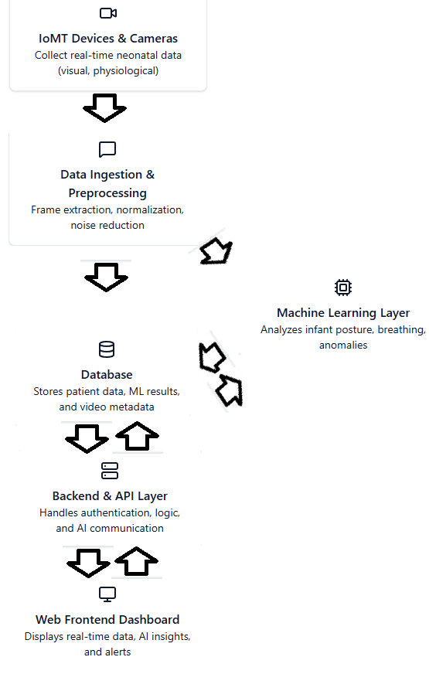
Workflow of the Software

4. User Profile
- AI Researchers
- Data Engineers
- NICU Clininicians
- Clinic IT/Adminstration

5. Anticipated Challenges & Constraints
- Technical Hurdles:
  - Real time data processing
  - Working with parallel data streams
  - Efficiently storing and querying large volumes of time-series, video, and AI-generated metadata in a compliant database system.
  - Maintaining uninterrupted operation despite variable hospital network conditions and ensuring robust reconnection mechanisms.
- Time/Resource Limits:
  - Limited access to high-performance GPUs and processing nodes may constrain real-time AI inference and model retraining capabilities.
  - Continuous video and sensor data collection from multiple NICU units can rapidly consume available disk space, requiring periodic data archiving or cloud-based storage extensions.
  - High-resolution video streaming and frequent data synchronization could exceed local network throughput, especially during peak hospital activity.
  - The project depends on a small interdisciplinary team; delays may occur due to limited availability of domain experts, data engineers, or clinicians for validation phases.
  - Deployment within an operational NICU requires restricted testing access and simulated datasets to avoid interference with clinical workflows.
  - Integration, testing, and validation phases must align with hospital schedules and regulatory approval processes, potentially extending the project timeline.
- Ethical or regulatory considerations:
  - Working with patient health data has legal constraints like GDPR
  - Guaranteeing end-to-end encryption and secure authentication in software-level.

6. Economic, social, environmental, legal, health, security impacts
In Neonatal Intensive Care Units (NICUs), the disparate nature of medical device data, sensor readings, and Hospital Information Systems (HIS) presents a significant challenge. This fragmentation hinders clinicians from achieving a comprehensive, real-time understanding of a newborn's medical status. Consequently, the efficacy of AI-driven diagnostic and monitoring systems is diminished, and the speed and consistency of clinical decision-making are adversely affected. Therefore, there is a critical need for a secure, integrated, and real-time digital support infrastructure capable of unifying all NICU data sources under standardized communication protocols.

7. Data Sources

IoMT device data (respiratory, cardiac).

Ultrasound images (DICOM).

Pulse oximetry signals.

